**MUTHU KUMAR**

**Android Developer**

Chennai, IN

**+91 9962822439**

[muthukumar.v23@gmail.com](mailto:muthukumar.v23@gmail.com)

**7+ YRS EXP | Immediate joiner**

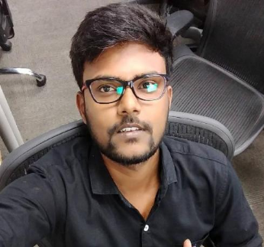

Having 7.3 Years of experience as an Android Development in software industries. Expertise in developing Mobile Application for Android Released 20+ Apps in Google play store Ability to quickly grasp any new technologies and concepts Strong programming, analytical and interpersonal skills Effective in working independently and collaboratively in teams

## KEY SKILLS

ACHIEVEMENTS

**Debugging contest**

Sep 2014

I went to college level contest in Theni College of Arts And Science .I started to go through the set of java code in notepad I can easily analysis the just by seeing the code. Then i can step forward to fix the issues one by one that program got run i won first prize in that contest for debugging.

# Kotlin Java

**XML Basics**

## CERTIFICATIONS

**Java SE Certification QTech Software solution** Sep 2014

# Knowledge of Git Retrofit Jetpack libraries

## PROFESSIONAL EXPERIENCE

**Senior Android Developer**

**ValueCoders Software Development Company**- Gurgaon, IN

Parent Company **: Vinove Software & Services LTD**

May 2021 - Present

*Our offerings include web solutions that enable our clients with a highly customized web page, mobile applications built with the latest technologies*

Understanding and analyzing the business Requirements.

Involved in designing database and business logic for all modules.

I have gained the experience of module ownership throughout the entire cycle

Work on bug fixing and improving application performance

Collaborate with cross-functional teams to define, design, and ship new features

Involved in Developing Business logics and DB modeling.

## LANGUAGES

**Tamil**

Native

# English

Fluent

## IN 7 YEARS

Implemented features for various applications in Java, Kotlin Worked with core technology teams other platform teams to balance cross-platform consistency with Android-optimization Implemented Clean Architecture using Dagger2 and Rxjava Reviewed design specs and engineering docs and provide feedback

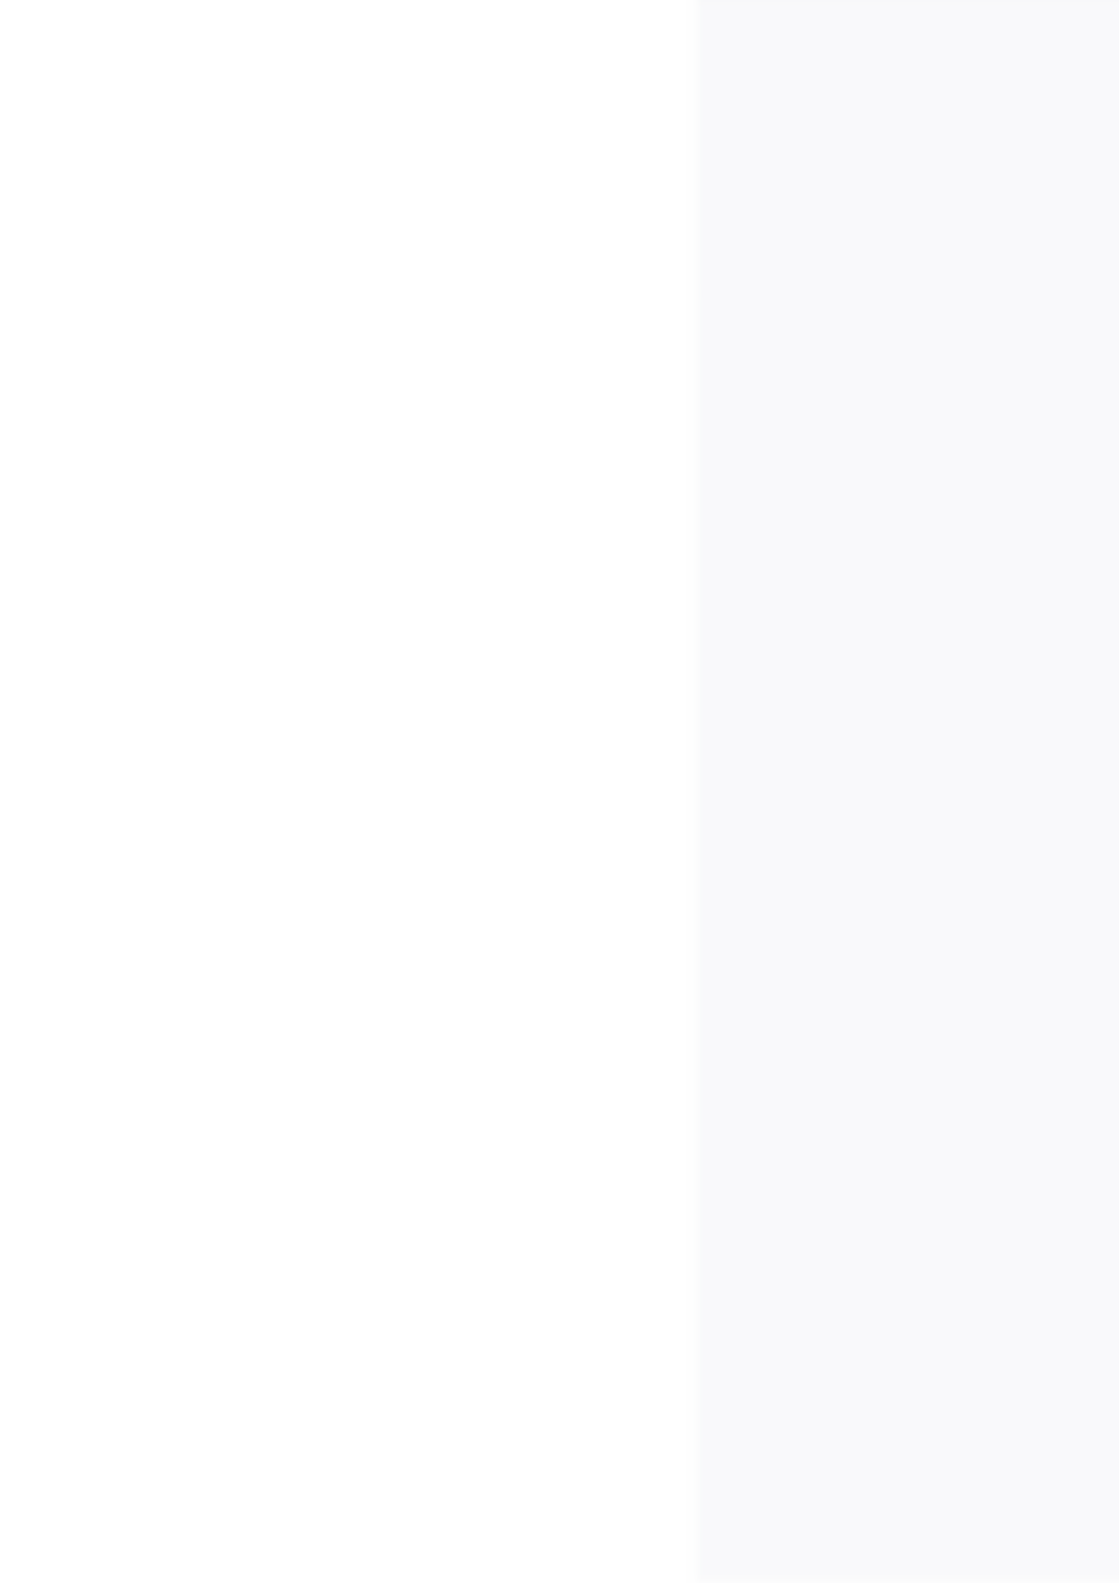**Senior Android Developer**

**Tranxit Technology -** Chennai, IN Aug 2018 - 2021

*Our offerings include web solutions that enable our clients with a highly customized web page, mobile applications built with the latest technologies*

Understanding and analyzing the business Requirements.

Involved in designing database and business logic for all modules.

I have gained the experience of module ownership throughout the entire cycle

Work on bug fixing and improving application performance

Collaborate with cross-functional teams to define, design, and ship new features

Involved in Developing Business logics and DB modeling.

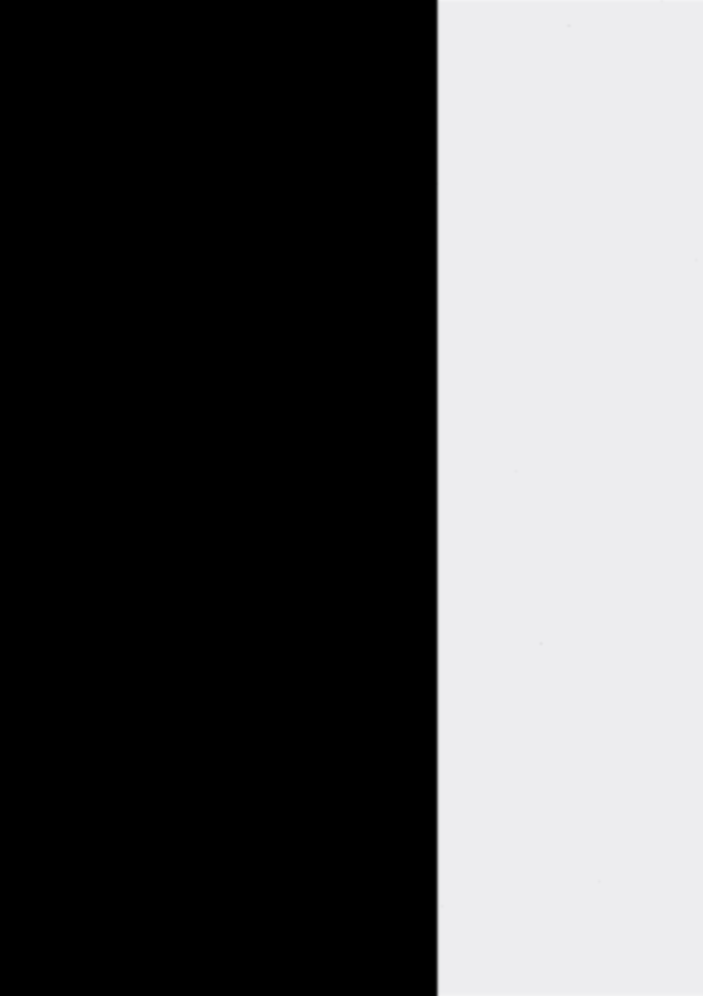**Android Developer**

**Brainmagic infotech pvt ltd -** Chennai, IN Jul 2015 - Aug 2018

*Brainmagic is a mobile application development and web application development company in chennai. We are providing services of software development*

Design and build advanced applications for the Android platform

Work with outside data sources and APIs

Work on bug fixing and improving application performance

Continuously discover, evaluate, and implement new technologies to maximize development efficiency

## PROJECT EXPERIENCE

**Foodie App**

## Jul 2018 - Dec 2018

*The foodie app is the essential companion for the modern sociable foodie. Discover a fun and fast way to spice up the perfect memory of a perfect meal*

* I have gained the experience of module ownership throughout the entire cycle
* Worked on bug fixing and improving application performance
* Involved in android coding to develop app UI and functionality.
* Understanding and analysing the business Requirements

SOFTWARE

Android studio 100%

Eclipse 75%

Adobe Photoshop 40%

ITS SKILLS

**Google API**

* Google Map
* FCM & GCM
* Push Notification

**Database**

* SQLite ( Room)
* Firebase
* MySQL

**Libraries**

* Jetpack libraries
* Retrofit
* Volley
* Glide
* Coroutine
* RxJava
* Stripe payment

**Others**

* HTML
* JSON
* XML

## STRENGTHS

**Creativity**

Thinking outside of the box and coming

up with creative solutions can be a real

asset in any role

**Teamwork**

Enjoy working as a team member as well as independently.

**Problem Solving**

Ability to use appropriate methods to

tackle unexpected challenges in an

organized manner..

**Inventory App (Infosys)**

## Mar 2020 - Jan 2021

*The Mobile Inventory App allows Receivers and Team Members the flexibility to check pricing, Store on-hands, locate product shelf locations, receive/transfer merchandise, print shelf labels, create Pick Lists, and adjust inventory anywhere in the Store.*

.

* Involved in android coding to develop app UI and functionality
* Continuously discover, evaluate, and implement new technologies to maximize development
* Unit-test code for robustness, including edge cases
* Involved RxJava library for composing asynchronous and event-based code
* Added SonarQube for code coverage
* Learned Onion clean architecture

**Dubai Police Chat application**

## Mar 2020 - Jan 2021

*The Dubai Police App is our official smart channel to access to chat. Our app just got more intuitive with the newly added features and services for better experience and enhance usability*

.

* Design and build advanced applications for the Android platform
* Work with outside data sources and APIs
* Unit-test code for robustness, including edge cases
* Involved RxJava library for composing asynchronous and event-based code
* Work on bug fixing and improving application performance

## EDUCATION

**BSC computer science Manonmaniam Sundaranar University** Gov Arts and Science College Thoothukkudi, IN

Apr 2011 - May 2014 GPA **3.4** 4.0

DECLARATION

*I hereby declare that the information furnished above is true to the best of my knowledge*

**Place:** Chennai Yours faithfully

**Date: Muthukumar.V**

SOCIAL MEDIA

# [Linkedin](https://www.linkedin.com/in/muthukumar-v-997bb8a7)

[**in/muthukumar-v-997bb8a7**](https://www.linkedin.com/in/muthukumar-v-997bb8a7)

# [Github](https://github.com/muthu23?tab=repositories)

[**muthu23?tab=repositories**](https://github.com/muthu23?tab=repositories)

# [facebook](https://www.facebook.com/profile.php?id=100004047112244)

[**profile.php?id=100004047112244**](https://www.facebook.com/profile.php?id=100004047112244)

HOBBIES & INTERESTS

 Bike riding Gymming

PERSONAL INFO

**Address:**

3/53/3 SS Flats 3th Floor,

TNGEO Colony Adambakkam Chennai – 600088

**Alter Phone:**

+91 6380896261

**Alter Email:**

Muthukumar.vv23@gmail.com